CS 255 System Design Document Template

UML Diagrams

UML Use Case Diagram
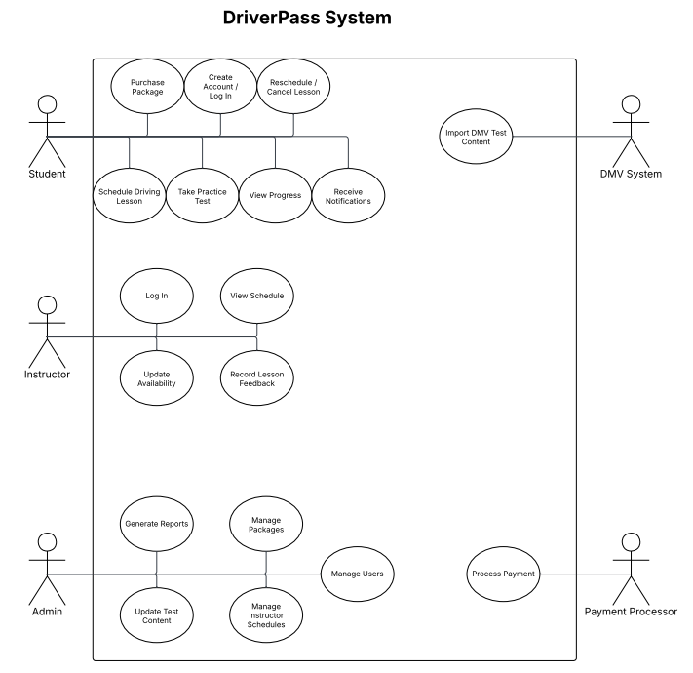

UML Activity Diagrams
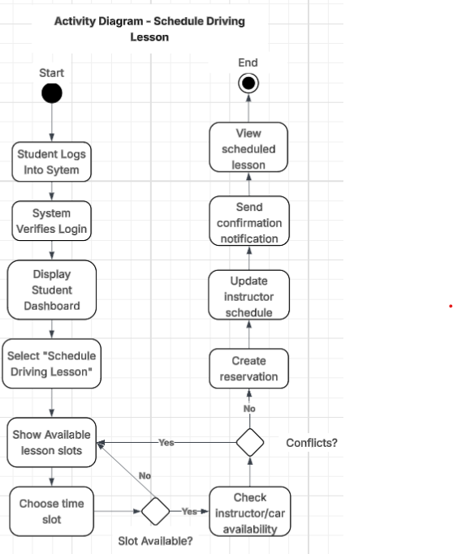
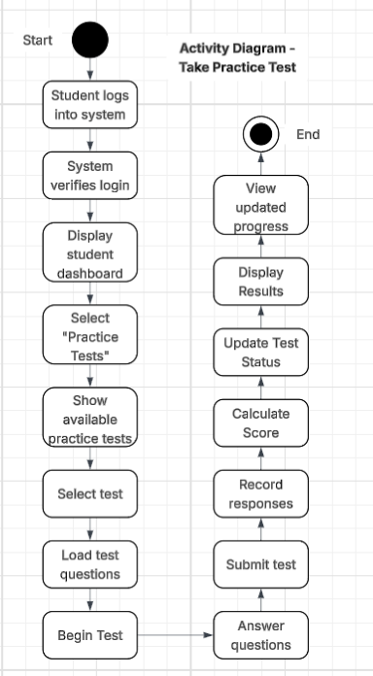

UML Sequence Diagram
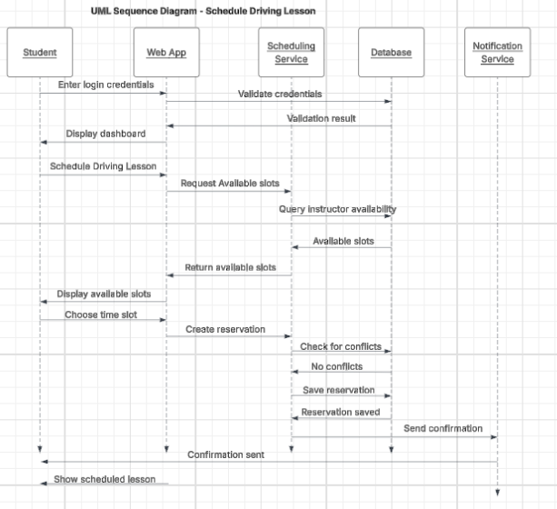

UML Class Diagram
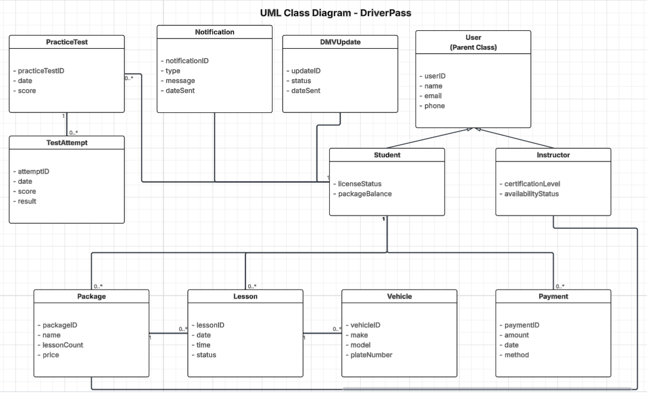

Technical Requirements
The DriverPass system requires a combination of hardward, software, development tools, and infrastructure components to support user authentication, scheduling, lesson management, notifications, and data storage. The following technical requirements are based on the system’s UML diagrams and functional needs.

- Hardware Requirements
  - Client Hardware
    - Any modern desktop, laptop, tablet, or smartphone capable of running a web browser

  - Server Hardware
    - Cloud-hosted or on premises server capable of running web services and a relational database.

- Software Requirements
  - Client Software
    - Modern web browser available (Chrome, Edge, Safari, Firefox)

- Server Software
  - Web application framework (e.g. Java Spring Boot or .NET Core)
  - RESTful API layer to support communication between the Web App and backend services
  - Relational Database Management System (MySQL, PostgreSQL, SQL Server)

- Notification Software
  - Email/SMS delivery service
  - Integration API for sending lesson confirmations and updates
- Development Tools
  - UML modeling tool for system design and documentation
  - Version control system with repository hosting (Github)
  - IDE or code editor (Visual Studio, Eclipse)
  - Testing tools for debugging
- Infrastructure Requirements
  - Application Hosting
    - Cloud platform (Google Cloud or AWS)
    - Load balancer to distribute traffic during high usage periods
  - Database Infrastructure
    - Managed SQL database
    - Automated backups and recovery
    - Role-based access control
  - Security Infrastructure
    - HTTPS encryption for client/server communication
    - Secure authentication
    - Firewall and intrusion detection for backend services
    - Data validation to prevent injection attacks
  - Scalability and Reliability
    - Auto scaling for web and scheduling services
    - Redundant servers or cloud availability zones
    - Monitoring and logging tools

